SIMATS ENGINEERING
ASSESSMENT TOOL 2

COURSE NAME: Database Management Systems
COURSE CODE: CSA05

COURSE OUTCOME COVERED

CO1: Analyze DBMS architecture, different data models, schema types, and design ER/EER diagrams, relational schemas for case-based scenarios by identifying entities and relationships. (BL1, BL2)

Activity Tool : Concept Mapping (Medium)
Assessment Tool Weightage: 35%

Dr

QUESTIONS Total Marks: 50
Q.No | Question | Bloom's Level | Marks
1 | Construct a concept map linking the following terms: DBMS, Schema, Instance, Data Model, ER Diagram, Entity, Attribute, Relationship. | BL2 – Understand | 5
2 | Create a concept map for the three-level ANSI/SPARC architecture showing data independence at each level. | BL2 – Understand | 5
3 | Map the relationship between file-based systems and database systems, highlighting the problems solved by DBMS. | BL2 – Understand | 5
4 | Design a concept map for ER diagram components: entity, weak entity, attribute types, relationship types, and participation constraints. | BL2 – Understand | 5
5 | Construct a concept map comparing Hierarchical, Network, and Relational data models with their key properties. | BL2 – Understand | 5
6 | Develop a concept map for the EER model showing how it extends the basic ER model with generalization, specialization, and aggregation. | BL2 – Understand | 5
7 | Create a visual concept map for the DBMS software architecture, illustrating the flow from user request to data retrieval. | BL2 – Understand | 5
8 | Map the data models discussed in CO1 to real-world applications and explain the suitability of each model. | BL2 – Understand | 5
9 | Construct a concept map for schemas and instances, showing how they relate to physical and logical data independence. | BL2 – Understand | 5
10 | Design a concept map for the roles and responsibilities in a DBMS environment: DBA, End User, Application Developer. | BL1 – Remember | 5

Code of Conduct:

I__K.Tejaswi__ (Name / Reg No) certify that this submission is my original work and that I have adhered to the guidelines specified for this assessment.
I understand that any violation of academic integrity rules will result in disciplinary action.

Signature of the student:

RUBRICS FOR CALCULATION:

Criteria | Weightage | Level 4 (Exemplary) | Level 3 (Proficient) | Level 2 (Developing) | Level 1 (Beginning)
Concept Identification | 25% | Identifies all key concepts from literature accurately and comprehensively | Identifies most key concepts with minor omissions | Identifies limited concepts; some are irrelevant or missing | Fails to identify essential concepts
Linkages | 25% | Establishes clear, meaningful, and accurate relationships between concepts | Shows correct relationships with minor gaps | Relationships are weak, unclear, or partially incorrect | No meaningful relationships established
Organization | 20% | Concepts are well-structured hierarchically with logical flow and grouping | Mostly organized with minor structural issues | Some organization but lacks clear hierarchy | No logical organization or structure
Integration of Literature | 20% | Integrates multiple studies effectively to show connections and comparisons | Shows some integration of literature | Limited integration; mostly isolated concepts | No integration of literature evidence
Clarity | 10% | Concept map is clear, neat, visually structured, and easy to interpret | Generally clear with minor readability issues | Clarity is reduced; difficult to interpret in parts | Poorly presented and hard to understand

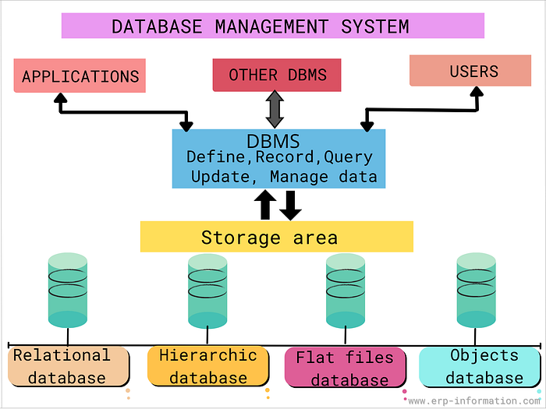

1.Ans ) DBMS and Related Components

A Database Management System (DBMS) is software that manages the storage, retrieval, security, and access control of data in a database. It ensures that data is organized and can be accessed efficiently.
The DBMS manages two important aspects:
1. Schema
- A Schema represents the logical structure of the database.
- It defines how data is organized in terms of tables, fields, and constraints.
- Schema is static (does not change frequently).
2. Instance
- An Instance is the actual data stored in the database at a specific point in time.
- It is dynamic and keeps changing as data is added, updated, or deleted.

Schema is based on Data Model
- A Data Model provides the rules and concepts for organizing data logically.
- It defines how data is connected, stored, and manipulated.

Example: ER Diagram
- An Entity-Relationship (ER) Diagram is a visual representation used to design the database structure.
- It helps in understanding how data is organized.

Components of ER Diagram
- Entity
  - An Entity is a real-world object.
  - Example: Student, Employee.
- Attribute
  - An Attribute is a property or characteristic of an entity.
  - Example: Name, Age, ID.
- Relationship
  - A Relationship represents the association between two or more entities.
  - Example: Student enrolls in Course.

Flow Summary (for writing neatly)
- DBMS → manages → Schema & Instance
- Schema → based on → Data Model
- Data Model → example → ER Diagram
- ER Diagram → consists of → Entity, Attribute, Relationship

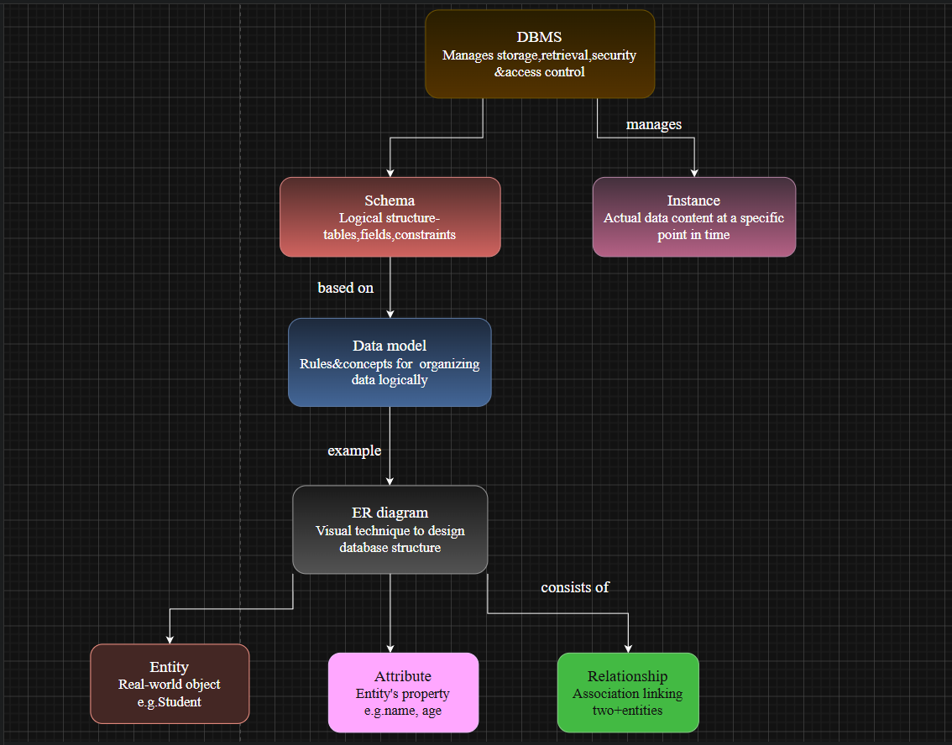

2.Ans) The ANSI/SPARC architecture divides a DBMS into three levels:

- External Level:
Provides different user views of the database.
- Conceptual Level:
Describes the overall logical structure (entities, relationships, constraints).
- Internal Level:
Describes physical storage (files, indexes, access paths).
- Physical Database:
Actual data stored on disk.

Data Independence
- Logical Data Independence:
Changes in conceptual schema do not affect external views.
- Physical Data Independence:
Changes in internal storage do not affect conceptual schema.

Conclusion
This architecture ensures data abstraction and independence, making the database flexible and easy to manage.
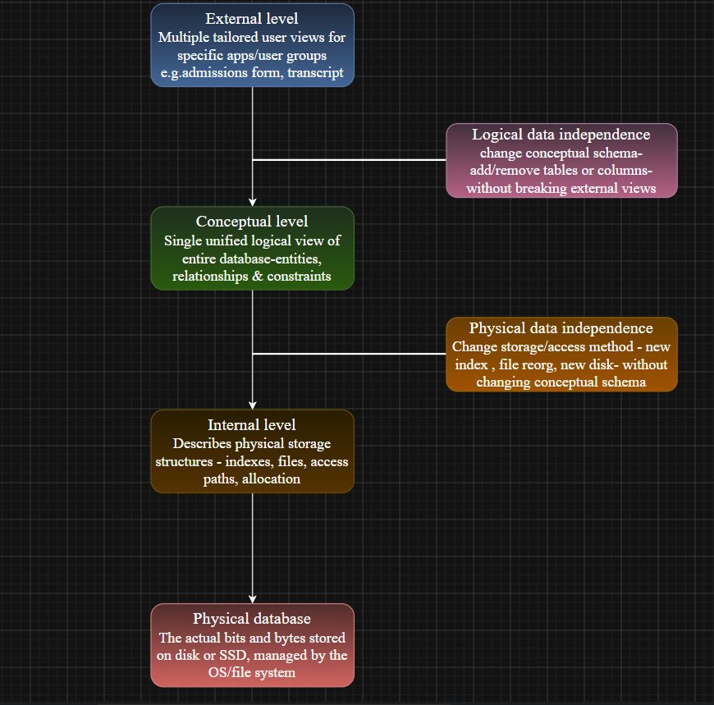

3.Ans) File-Based System vs Database System (DBMS)

A file-based system stores data in separate files, which leads to several problems. A DBMS overcomes these issues through centralized management.

Problems in File-Based System → Solution by DBMS
- Data Redundancy (duplicate data)
→ DBMS maintains a single consistent copy of data.
- Difficult Data Access (no query language)
→ DBMS provides SQL queries for easy access.
- Data Isolation (scattered files)
→ DBMS uses a unified schema for integration.
- Integrity & Atomicity Issues
→ DBMS supports transactions (ACID properties).
- Concurrency & Security Problems
→ DBMS provides concurrency control and access security.

Conclusion
DBMS replaces file-based systems by providing efficient, secure, and centralized data management, reducing redundancy and improving consistency.
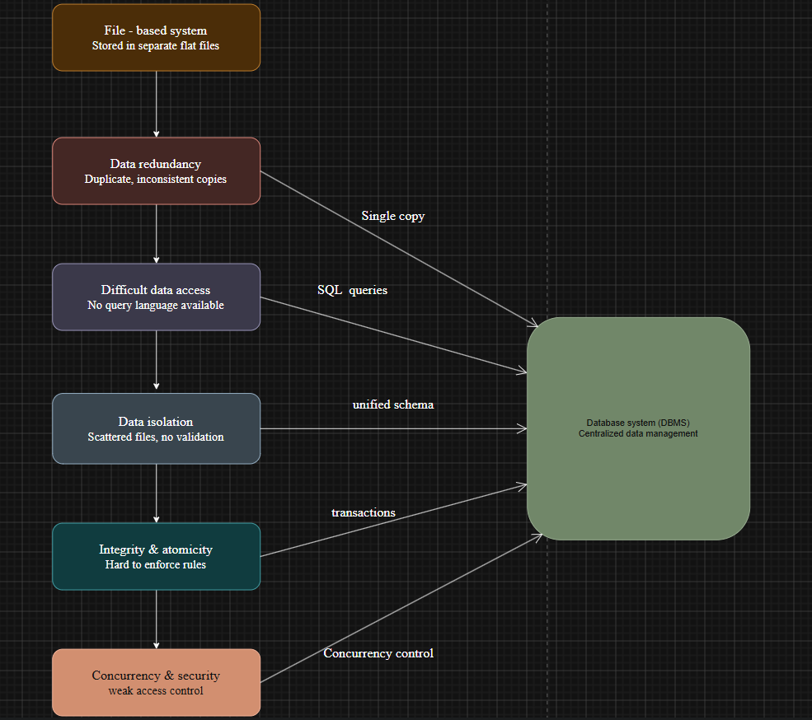

4.Ans) ER Diagram Components

An ER (Entity-Relationship) Diagram represents the core building blocks of database design.
1. Entity
- A real-world object (e.g., Student, Employee).
- Weak Entity:
  - Does not have its own primary key.
  - Depends on another (strong) entity.
2. Attributes
- Describe properties of an entity.
- Types of Attributes:
  - Simple: Cannot be divided (Age).
  - Composite: Can be divided (Name → First, Last).
  - Multivalued: Multiple values (Phone numbers).
  - Derived: Calculated (Age from DOB).
3. Relationships
- Show association between entities.
- Types:
  - One-to-One (1:1)
  - One-to-Many (1:M)
  - Many-to-Many (M:N)
4. Participation Constraints
- Define involvement of entities in relationships:
  - Total Participation: All entities must participate.
  - Partial Participation: Some entities may not participate.
Flow Summary
ER Diagram → Entity → Weak Entity
ER Diagram → Attributes → Types
ER Diagram → Relationships → Types
ER Diagram → Participation → Total / Partial

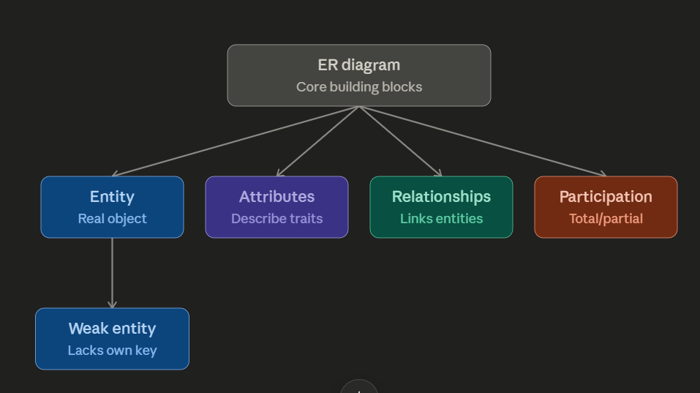

5.Ans) Data Models Comparison

Data models define how data is structured and organized in a database. The three main models are:

1. Hierarchical Model (Simple but Rigid)
- Structure: Tree structure
- Relationship: One-to-Many (1:M)
- Parent: Each child has only one parent
- Approach: Top-down
- Nature: Rigid and less flexible

2. Network Model (Flexible but Complex)
- Structure: Graph structure
- Relationship: Many-to-Many (M:N)
- Parent: A child can have multiple parents
- Links: Flexible connections
- Nature: Complex design

3. Relational Model (Easy and Powerful)
- Structure: Table format (rows & columns)
- Keys: Primary key & Foreign key
- Language: Supports SQL queries
- Nature: High flexibility and simplicity

Flow Summary
Data Models → Hierarchical / Network / Relational
- Hierarchical → Tree → 1:M → Single Parent → Rigid
- Network → Graph → M:N → Multiple Parents → Flexible
- Relational → Tables → Keys → SQL → High Flexibility

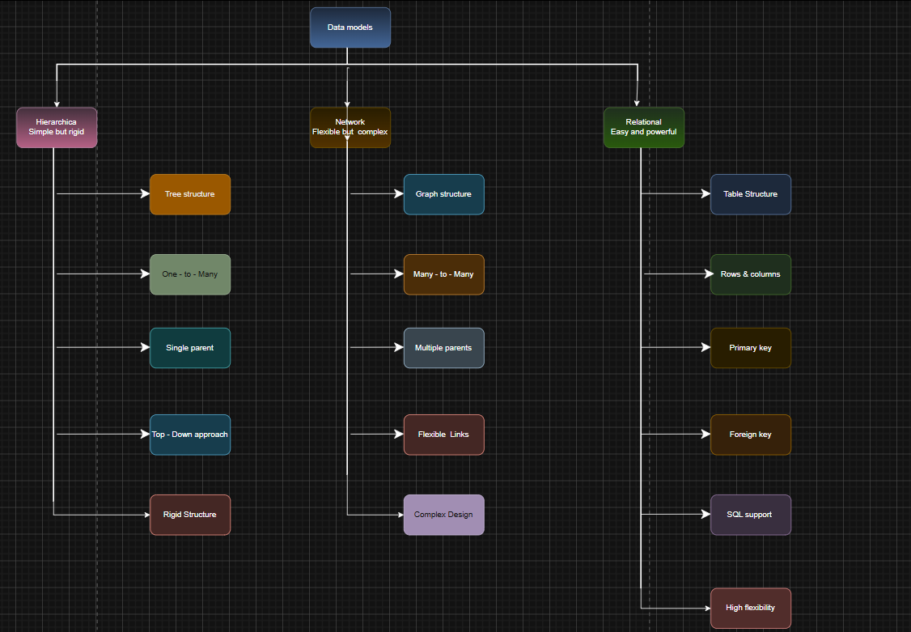

6.Ans) EER (Enhanced ER) Model

The EER Model is an extension of the basic ER model that adds more advanced concepts for better database design.
Base: ER Model
- Consists of:
  - Entity
  - Attribute
  - Relationship
Extensions in EER Model
1. Generalization (Bottom-Up)
- Combines multiple lower-level entities into a higher-level entity.
- Example: Car, Bike → Vehicle
- Focus: Common features
2. Specialization (Top-Down)
- Divides a higher-level entity into sub-entities.
- Example: Employee → Manager, Engineer
- Types:
  - Disjoint / Overlapping
  - Total / Partial participation
3. Aggregation
- Represents a relationship as a higher-level entity.
- Used when a relationship needs to participate in another relationship.
- Example: (Employee works_on Project) treated as one unit.
Flow Summary
ER Model → Extended by → EER Model
EER Model →
- Generalization (combine entities)
- Specialization (divide entity)
- Aggregation (relationship as entity)
Conclusion
EER model provides more abstraction, flexibility, and real-world representation than the basic ER model.

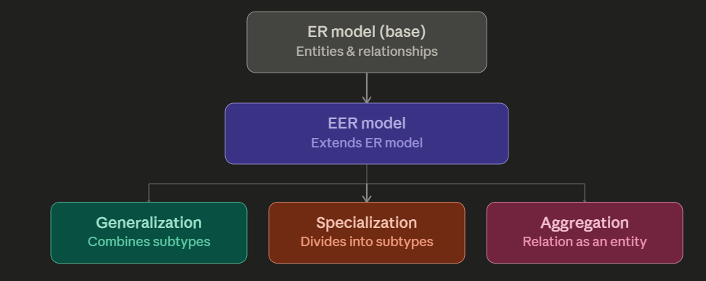

7.Ans) DBMS Software Architecture

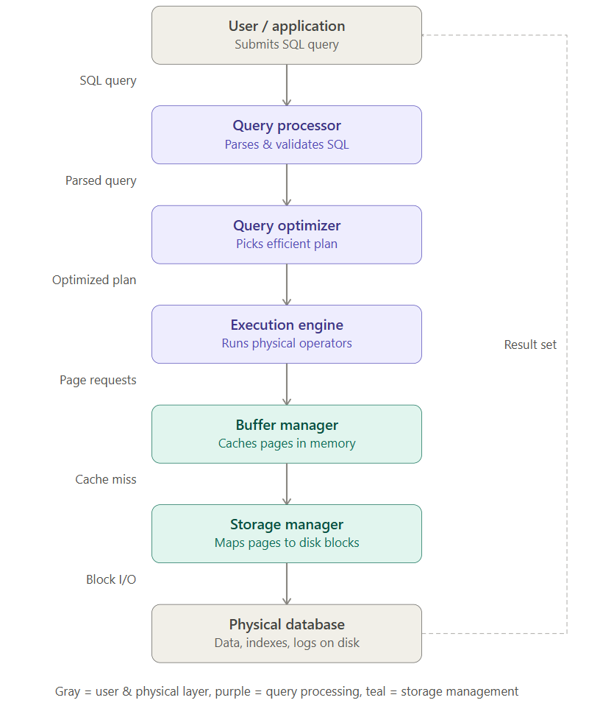

DBMS software architecture defines how a database processes a user query and retrieves data efficiently.
- The User/Application sends an SQL query to the DBMS.
- The Query Processor parses and validates the query.
- The Query Optimizer selects the most efficient execution plan.
- The Execution Engine executes the query operations.
- The Buffer Manager temporarily stores data in memory for faster access.
- The Storage Manager manages data retrieval from disk.
- The Physical Database stores actual data, indexes, and logs.
Finally, the result is returned to the user.
Conclusion
This architecture ensures efficient query processing, optimized performance, and fast data retrieval.

8.Ans) Data Models and Their Real-World Applications

Different data models are used based on application needs:
1. Hierarchical Model
- Application: File systems, Organization charts
- Suitability:
  - Best for structured, tree-like data
  - Works well when one-to-many relationships exist
  - Simple but not flexible for complex relationships
2. Network Model
- Application: Airline reservation systems, Telecom networks
- Suitability:
  - Supports many-to-many relationships
  - Suitable for complex interconnected data
  - More flexible than hierarchical but difficult to design
3. Relational Model
- Application: Banking systems, E-commerce, Student databases
- Suitability:
  - Uses tables (rows & columns)
  - Supports SQL for easy querying
  - Highly flexible, scalable, and widely used

Conclusion
Each data model is suitable for different scenarios:
- Hierarchical → simple structured data
- Network → complex relationships
- Relational → general-purpose and most practical use

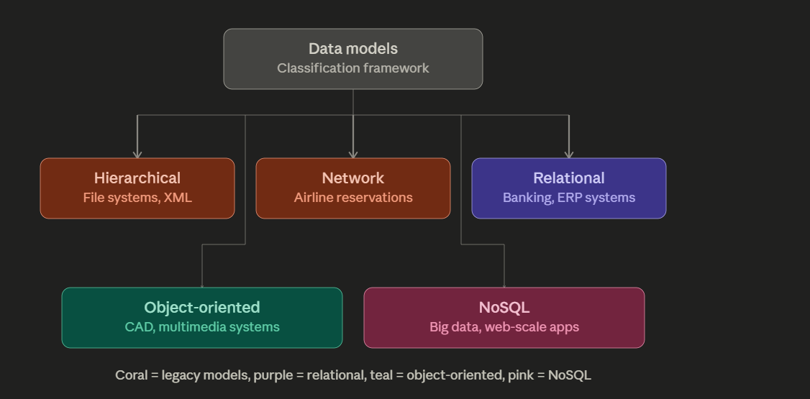

9.Ans ) Schema, Instance & Data Independence
- A Schema represents the structure of the database and changes rarely.
- An Instance is the actual data at a particular time and changes frequently.

Types of Schema
- External Schema:
User-specific views of the database.
- Conceptual Schema:
Overall logical structure (community view).
- Internal Schema:
Physical storage details of data.
Data Independence
- Logical Data Independence:
Changes in conceptual schema do not affect external schema (user views).
- Physical Data Independence:
Changes in internal schema (storage) do not affect conceptual schema.
Flow Summary
Schema → External / Conceptual / Internal
Instance → Actual data
External ↔ Conceptual → Logical Independence
Conceptual ↔ Internal → Physical Independence
Conclusion
This separation ensures flexibility, data abstraction, and easy database maintenance.

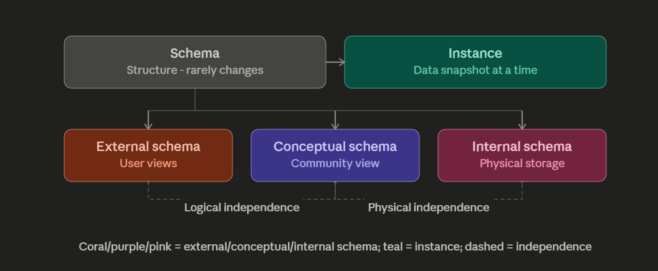

10.Ans) DBMS Environment (Roles & Responsibilities)

A DBMS environment involves three main roles: DBA, Application Developer, and End User.
1. DBA (Database Administrator)
- Manages the overall database system
- Defines schema and storage structures
- Handles authorization, security, and backups
2. Application Developer
- Builds database applications
- Writes programs with embedded SQL queries
- Uses DML and APIs to interact with the database
3. End User
- Interacts with the database through applications
Types of Users:
- Naive Users: Use forms and applications
- Advanced Users: Execute ad-hoc queries

Flow Summary
DBMS Environment → DBA / Application Developer / End User
- DBA → Schema + Security
- Developer → Programs + SQL
- End User → Uses data

Conclusion
Each role ensures efficient database design, development, and usage.

